Electron Cutout Measurements

# Purpose

This procedure lists the steps taken in using a PP ion chamber to calculate MU for treatment with a custom electron cutout on Elekta.

If the PP chamber is unavailable, you can (less accurately) perform the calibration using the DailyQA3 device. Blue steps apply only to the PP chamber; orange steps, only to DQA3.

# Steps

## In Physics

1. For custom cutouts, print a copy of “Electron Cutout Measurements Worksheet.”
2. Fill out the following fields on the worksheet: patient, MR#, Rx name, machine, e- energy, measurement unit, cone size, and cutout SSD.
3. Get the cart with the solid water out of the hot lab. The hot lab key is in the cabinet to the right of Kaley’s desk.

## At Elekta Console

1. Exit MOSAIQ if it is open.
2. Log out of Clinical mode on the Elekta computer.
   1. Click *Exit*.
   2. Click the Log Off icon.



* 1. Click *Yes*.

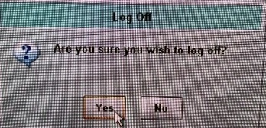

1. Log in to Service mode using username and password *service*.
2. Click the Service Functions icon.

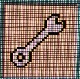

1. Click the Deliver Quick Beam icon.

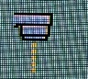

1. On the Radiation tab, select ELECTRONS as the Radiation Type. Select the appropriate energy. Set Beam MU1 to 100. Do not set an MLC shape.

## In Elekta Treatment Room

1. Set gantry and collimator to 0°.
2. Place indexing bar at location 2 on tabletop.
3. Place a 10 cm backscatter base against the bar on tabletop. (The easiest way is with a 6 cm and a 4 cm block.)
4. Place the block with the hole for the PP chamber, on top of the backscatter block.
5. Open the black box that contains the PP ion chamber. Unscrew the clear cap from the chamber and screw on the cap with a hole in the middle. Do not touch the center of the ion chamber!
6. Remove the yellow cap from the ion chamber cable and the cap from the white triax cable from inside the Engineers Room. Connect the ion chamber to the triax cable.
7. Place ion chamber into solid water.
8. Turn on the crosshair if necessary. In the linac software, on the **MLC** tab, set the field to the applicator size.
9. Align ion chamber/DQA3 device to the crosshair. There are marks on the sides of the solid water to help align the y-laser. Align the x-laser with the middle of the hole in the solid water.
10. Add Dmax thickness in solid water on top of chamber. Use the following table to determine Dmax for your given energy. (The table is also on the worksheet.)

|  |  |
| --- | --- |
| **Electron Energy (MeV)** | **Dmax (cm)** |
| 4 | 0.9 |
| 6 | 1.3 |
| 9 | 2 |
| 12 | 2.5 |
| 15 | 3.5 |
| 20 | 4.7 |

DQA3 has 1 cm solid water built in, so subtract 1 from the Dmax in the table above. Do not place solid water over small hump on DQA3 device. Double check levelness with a level.

1. Insert the 10×10 applicator into the gantry.
2. Insert standard cutout into applicator. Lift handles to vertical and lift yellow hook upward to insert, and lock handles horizontal to secure. The treads of the cutout must face upward, and the triangle on the cutout must be under the white block in the applicator.
3. If lasers are not on, turn them on by pressing the ISO CNTR button on hand pendant. If lasers are hard to see, turn off some lights.
4. Use the ODI (**DIST** button on hand pendant) to set the solid water/DQA3 device to 100 SSD. King’s rule of thumb: when solid water is aligned, you should see dust on the top on the top of the solid water.

## At Elekta Console

1. Plug in electrometer using white triax cable. Turn on electrometer.
2. Electrometer should display RANGE. For pC, set the RANGE to LOW; for nC, set to HIGH. Press the down arrow to set the range.
3. Zero electrometer by pressing the MODE/ZERO button and then the START/RESET button when prompted. This process will take a couple minutes. When zeroing is finished, electrometer will display “Zero Complete.”
4. Press the MODE/ZERO button until *Bias* is displayed on top.
5. Double check that the PP chamber is connected to the electrometer. Then set bias to -300 using the down arrow button. The bias has reached the set value when the value is inside the parentheses.
6. Press the MODE/ZERO button on the electrometer until *Chrg* is displayed. Ensure charge is ------ pC/nC.
7. Check for interlock by clicking the middle bar in the bottom left of the screen. The *Appl.*  Warning indicates applicator interlock.
8. Ensure that PDI Host is running. Log into SunCheck.
9. Start a *Daily* QA task for the appropriate linac (E1 or E2).
10. Collect background.
11. Scroll down to the appropriate electron energy. Click *Activate QA Task*.
12. Take the open field measurement.
    1. On Elekta computer, *Confirm*.
    2. Wait for the top stripe at the bottom left of the Elekta computer to turn green. If the stripe will not turn green, ensure that doors to Engineers Room and treatment room are closed and that nothing is set on the MLC tab. You can also click the bar to see the list of inhibits.

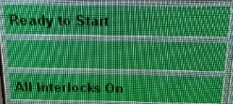

* 1. Click START/RESET on the electrometer twice to set *Chrg* to 0.00.
  2. Click *Start Measurement*.
  3. Press the MV button on the Elekta console.
  4. When beam finishes, record the electrometer reading on the worksheet.
  5. When beam finishes, click *Stop* in SunCheck. Record the *Output/Dose* measurement on the worksheet. Note that this is in cGy, not the pC that is specified on the worksheet.
  6. Click *Next Beam*.
  7. Repeat steps (a)–(e) twice.

## In Elekta Treatment Room

1. Remove cutout from applicator. Set the handles to vertical and lift the yellow hook in order to remove.
2. Insert custom cutout into applicator. Cutout is either in the block room or in one of the cutout drawers in the E1 or E2 treatment room. Do not handle cutout without gloves.

## At Elekta Console

1. Click *Load*.
2. Repeat treatment room setup steps for custom cutout. This time, ensure that the ion chamber/center of DQA3 device is in the center of the light field.
3. Repeat output measurement steps for cutout.
4. Set electrometer bias to zero. Turn off and unplug electrometer.
5. Delete the Daily QA task in SunCheck.

## In Physics/Dosimetry

1. Calculate the output factor and record it on the worksheet.
2. Calculate the MU and record it on the worksheet. Following is an explanation of how to find each term in the equation.
   1. Dose (per fx): Double-click the Rx under D & I in MOSAIQ, or check the planning worksheet in Documents.
   2. Output factor: Calculated earlier.
   3. Percent isodose: Double-click the Rx under D & I in MOSAIQ, or check the planning worksheet in Documents.
3. Have a physicist do a secondary calc (repeat your calculation) and sign the worksheet.
4. Open the patient in MOSAIQ.

Go to *Chart*.

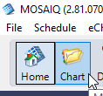

Navigate to the *Documents* tab.



1. Click *Add* and select *eSCRIBE*.

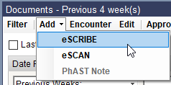

1. Set the Document Type to *D- Dose Calc*. Set Dictated By to yourself. Set Review Req By to the MD. Click *Edit*.

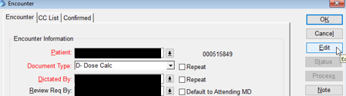

1. Select the *Physics* folder and click *Electron Measurement.dotx*. Click *OK*.

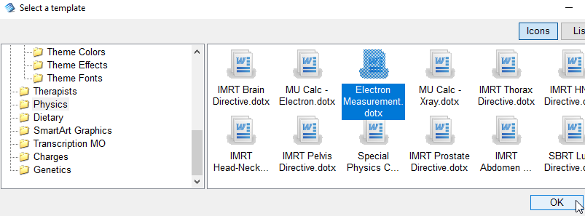

1. Use the worksheet to fill in the Electron Calibration Word document.
2. Navigate to the *Add-ins* tab and click *OK*.

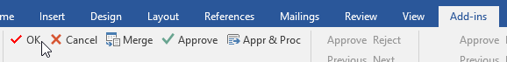

1. Select the new document in MOSAIQ and click *Status*.



1. Select *Review Req*, enter your password, and click *OK*.

